Download and Install Windows Server 2022

Introduction

Windows Server is Microsoft's enterprise server platform that enables organizations to run and secure applications, services, and workloads across on-premises, hybrid, and cloud environments.
Windows Server Data Center is best option for regulated industries, existing infrastructure, specialized hardware requirement and complete data control. For the lab set you can deploy Windows Server Standard with Desktop Experience.

Available Installation Options

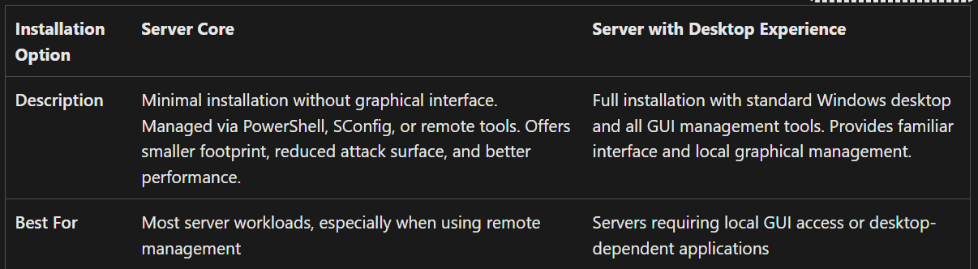

Download Windows Server 2022
- For all Microsoft Software Packages, the Azure Site can be connected through the following link:
https://azureforeducation.microsoft.com/devtools
- After you signed into Azure with your [username]@sheridancollege.ca Sheridan credentials and then choose the Software tab on the left side Navigation bar.
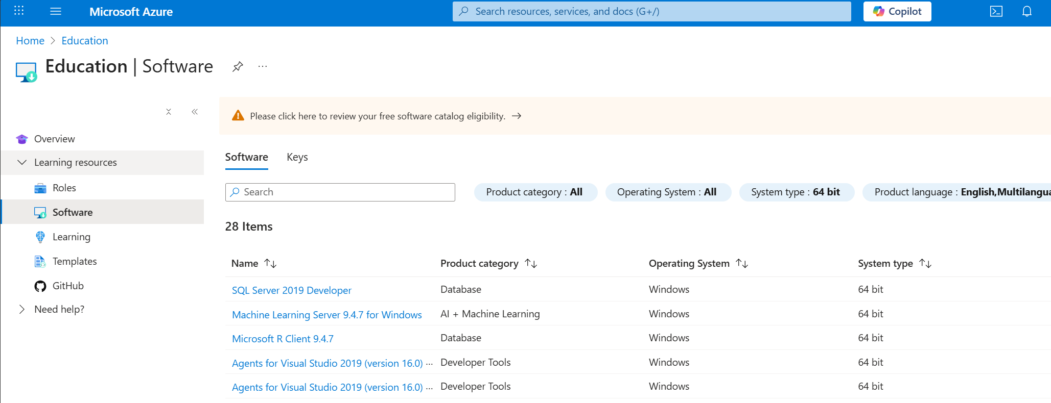
- Search for Windows Server Standard 2022.
- Download the ISO File and save the licence key.

Minimum Hardware Requirements for Windows Server
- C.P.U.
  - 1.4 GHz 64-bit processor
  - Support for NX and DEP
  - Support for Second Level Address Translation (EPT or NPT)
- RAM
  - 2GB for Server Core
  - 4GB recommended for Server with Desktop Experience.
- Storage
  - 32GB should be considered an absolute minimum value for successful installation
- Network
  - An ethernet adapter that can achieve a throughput of at least 1 gbps.

PowerShell Scripting Lab Setup
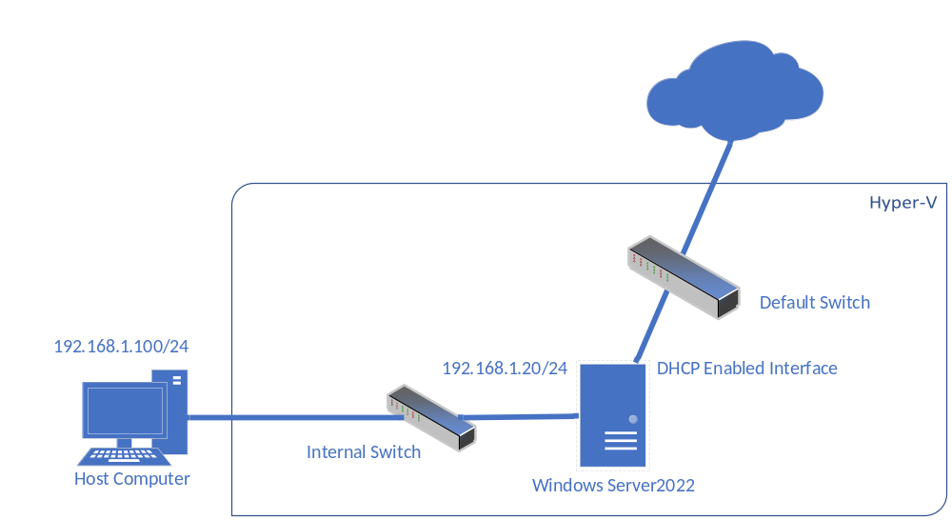
Create a Windows Server 2022 VM on Hyper-V
- Start Hyper-V Manager, under Actions Menu select New and then select Virtual Machine.
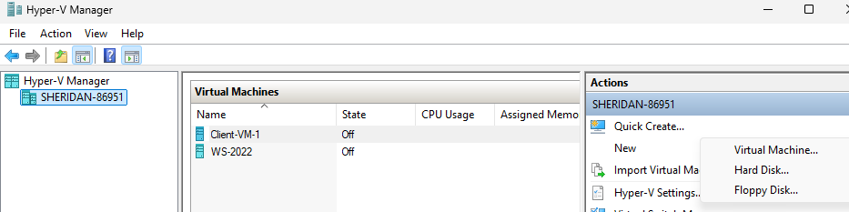

- Specify the name and location. Follow the naming convention DC-[FL]-WS2022. Replace FL with your initials. E.g. Alice Rose will name the VM as DC-AR-WS2022.
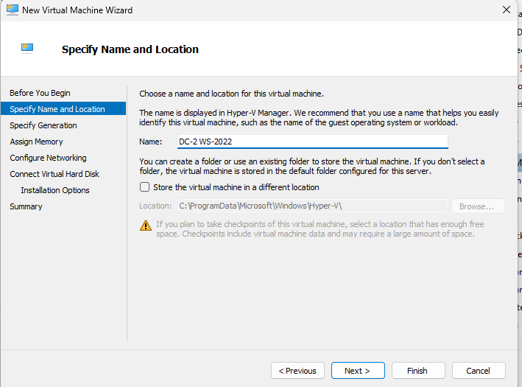
- Specify generation as Generation 2.
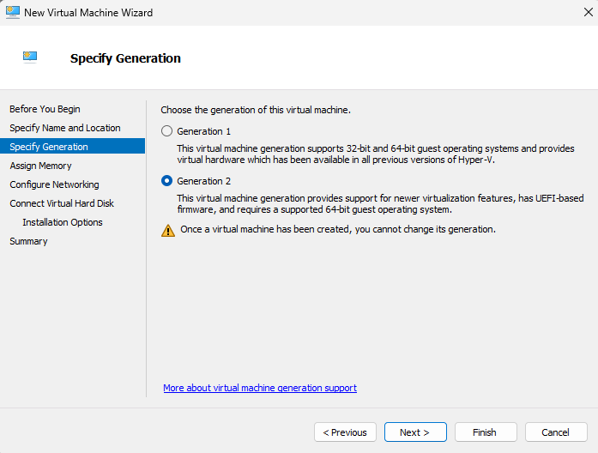
- Assign memory as 4096MB (4GB). Check the use Dynamic Memory doe this virtual machine.
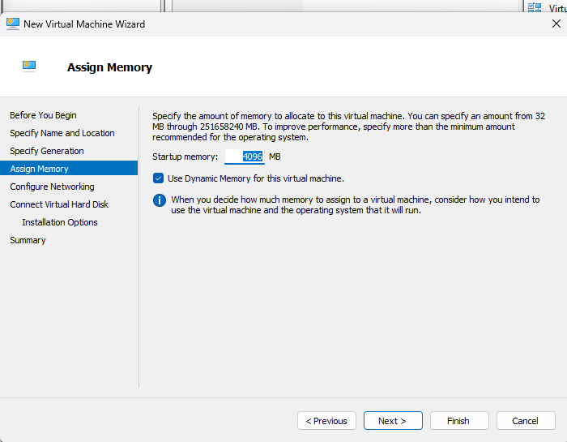
- Configure Networking with connection as Default Switch.
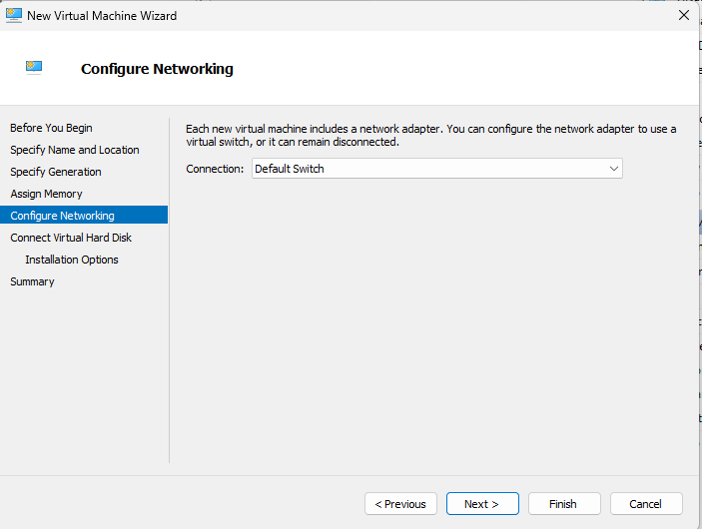

- Create virtual hard disk with 32GB (minimum requirement).
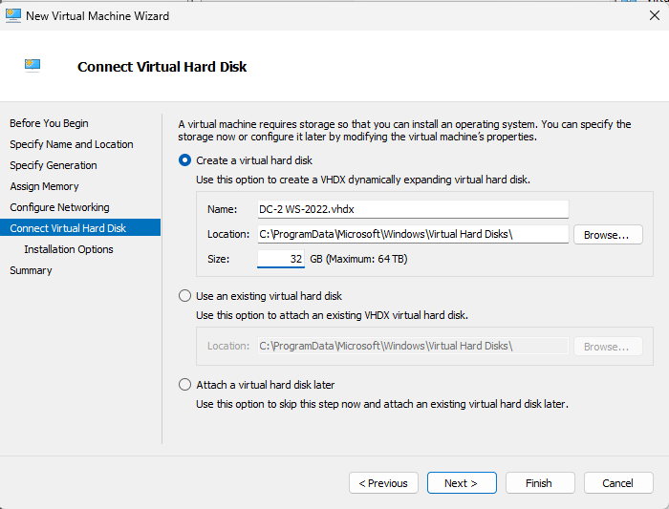
- Install an operating system from a bootable image file. Browse to the location where you have downloaded the ISO image.
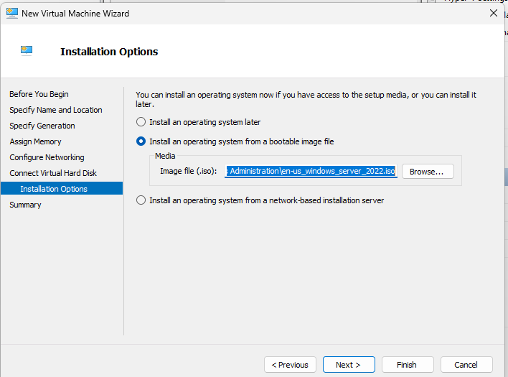
- Review the summary. Complete the creation of Virtual Machine by clicking on Finish.
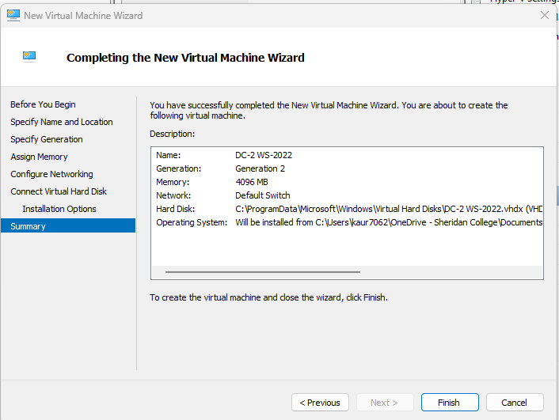

Install Windows Server 2022.
- To install Windows Server 2022, Power on the VM.
- Right Click on the VM and Select Connect.
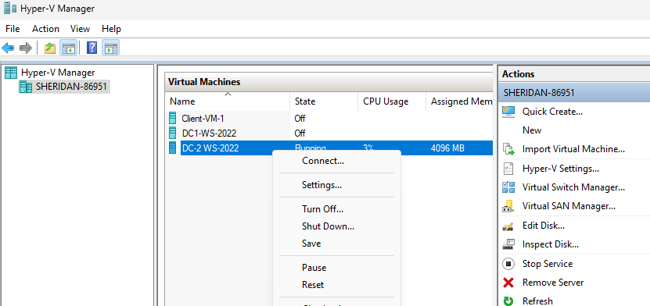
- If there is an UEFI error. Reset the VM from the Action Menu.
- When resetting it will show the following window
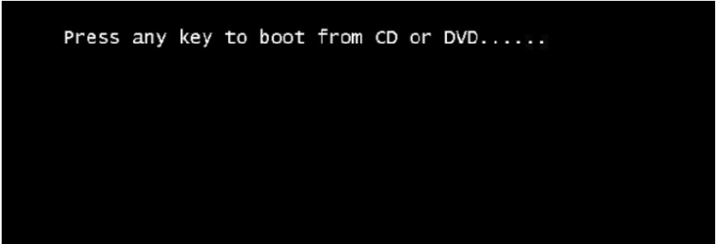
- Once the OS is booted correctly it will show the following window.
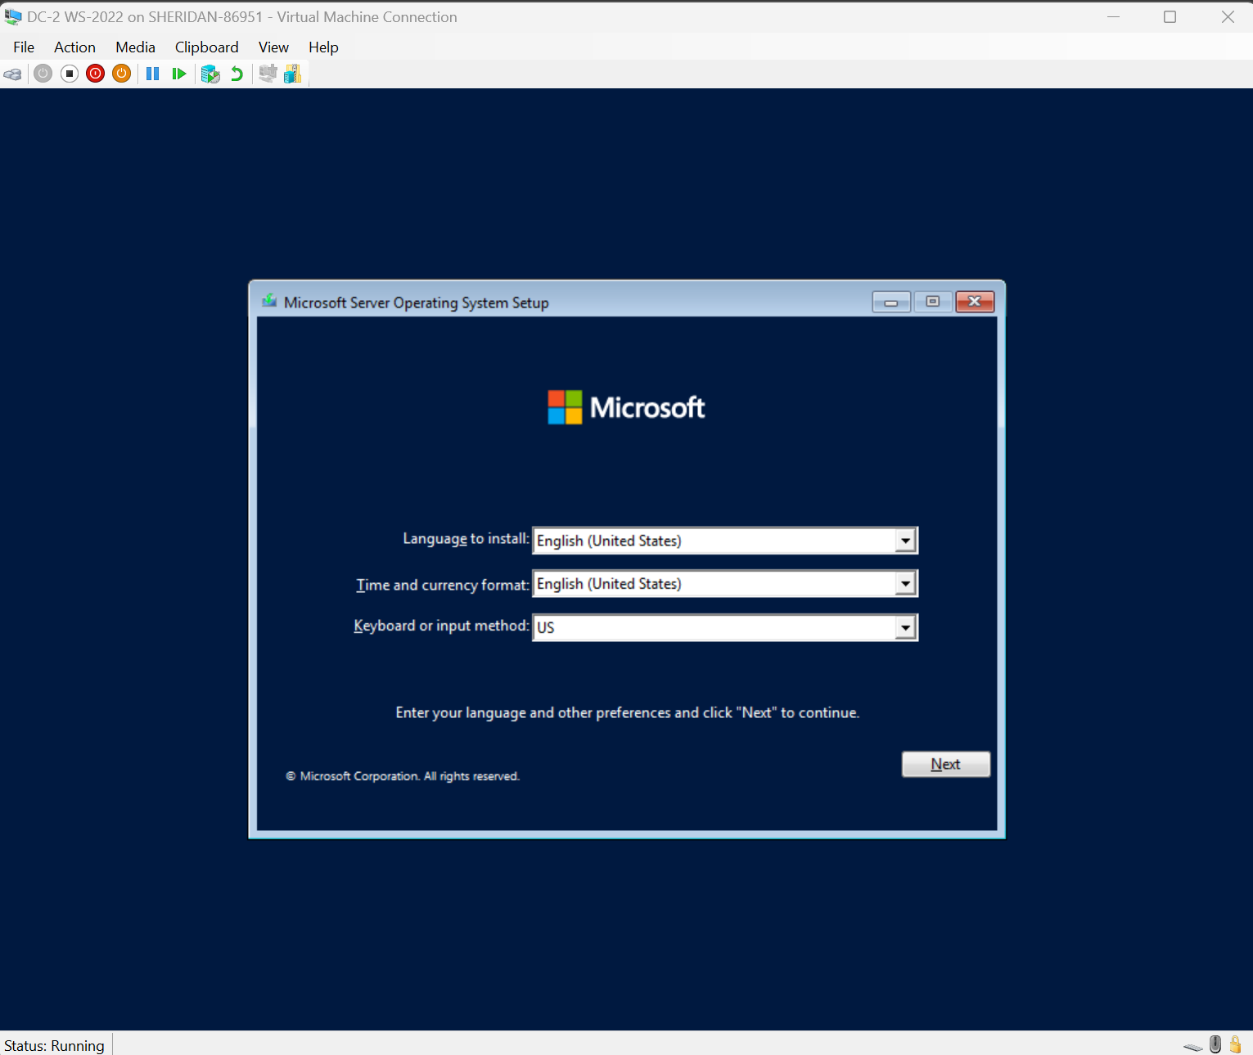
- Choose a language of your choice in the window that pops up then click “Next”.
- Click the ‘Install now’ button on the next window, to initiate the installation process for Windows Server.
- On the next window, enter the license key and click “Next”.
- Select a Windows Server 2022 Standard (Desktop Experience) and then click ‘Next’.
- Accept the Microsoft Software License Terms and click ‘Next’.
- Choose the Custom: Install Microsoft Server Operating System only (advanced)
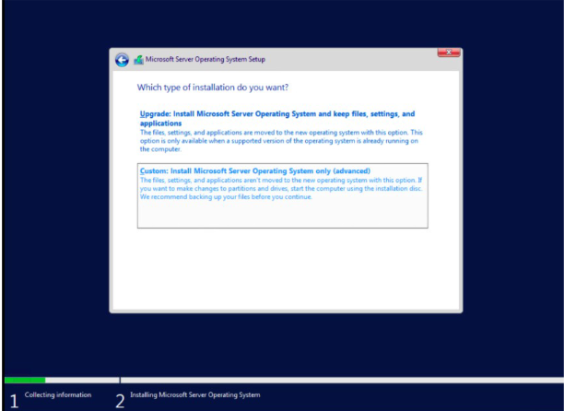
- Select a partition to install Window Server, you can optionally create new one from available size and click ‘Next’.
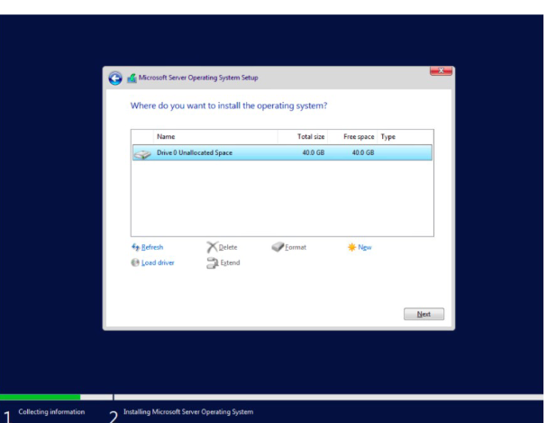
- The installation process will start. It will take some time and system should reboot.
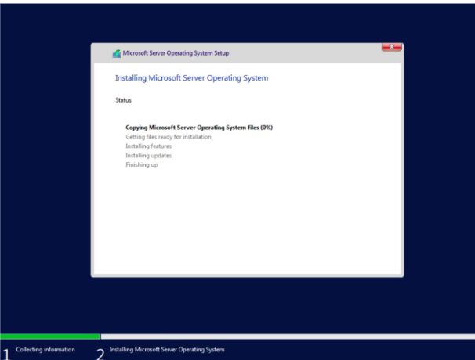
- Configure the Administrator password. Input the password and re-enter the password for verification.
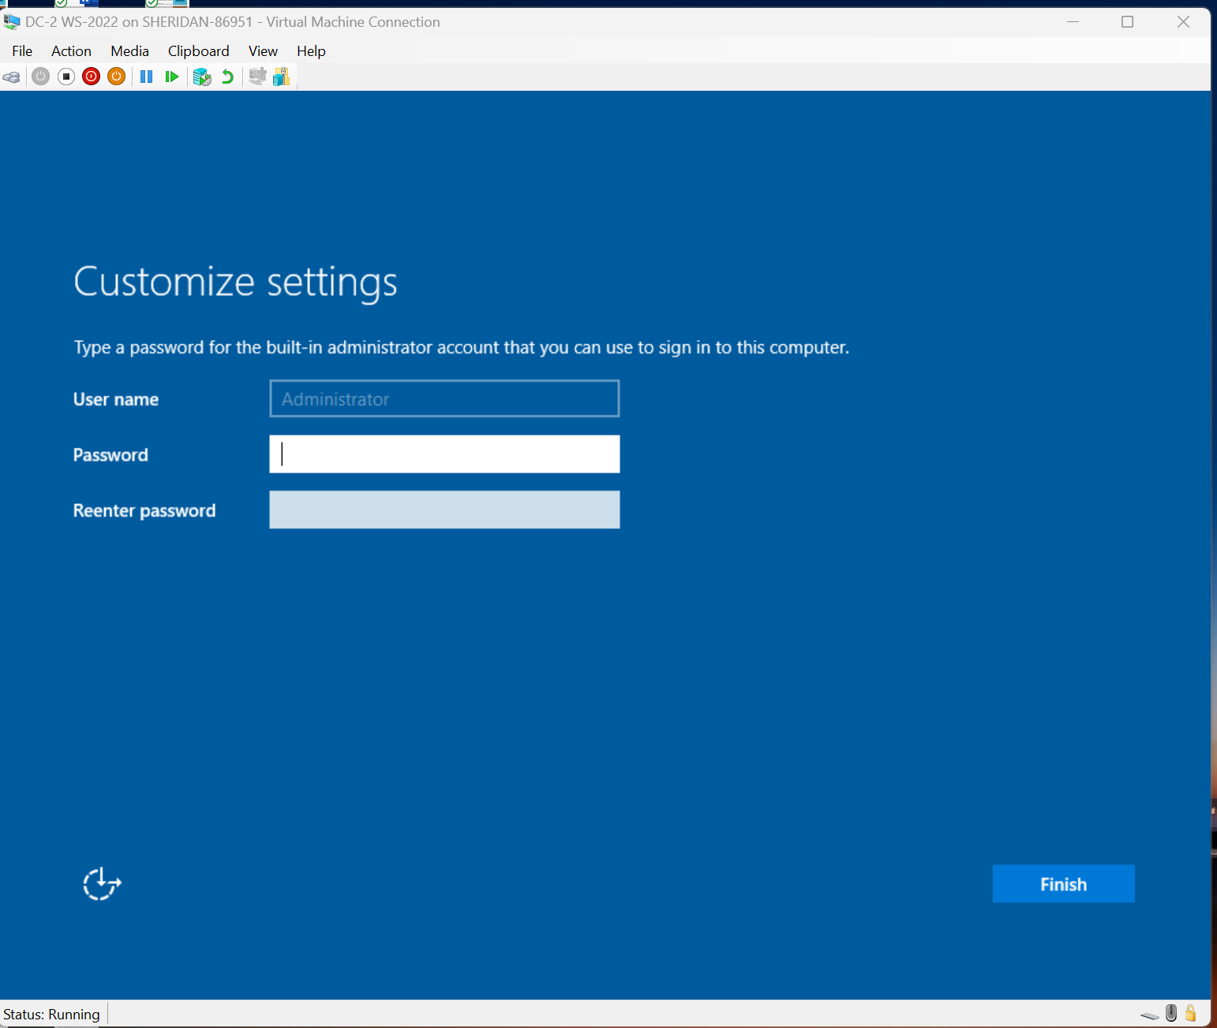

Initial Configuration on Windows Server.
- Add another Network Adapter and connect it to the internal switch.

Creating Internal Network Switch on Hyper-V
- On Hyper-V Manager, Select Virtual Switch Manager.
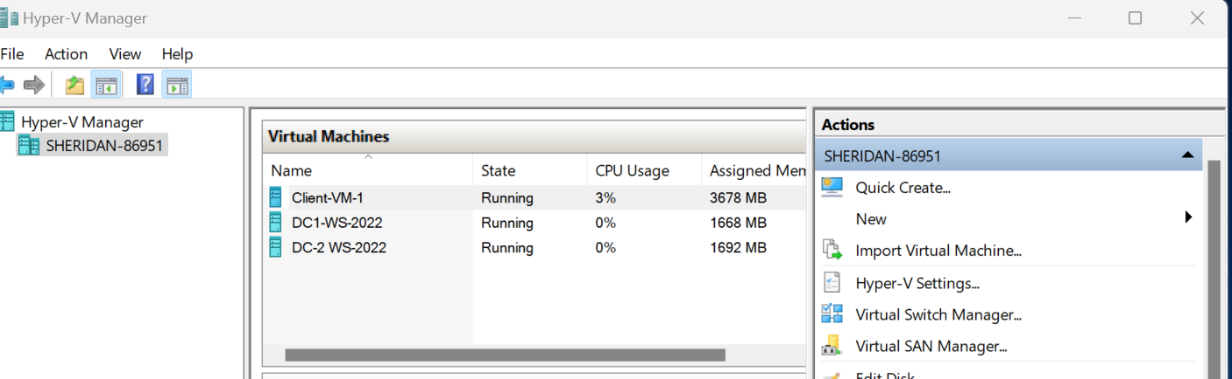

2.Create a New Virtual Network Switch of Internal type.
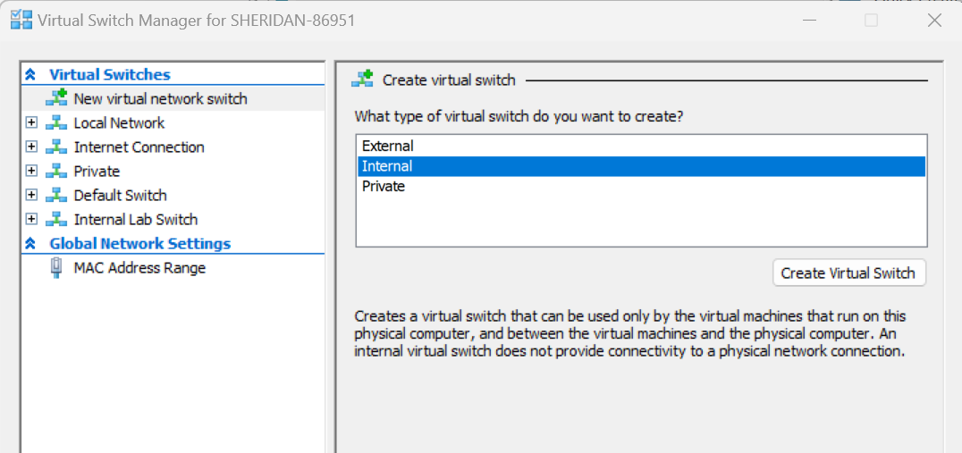
- For all the virtual machines, Change the network settings to Internal Lab Switch (Switch created in step 2)
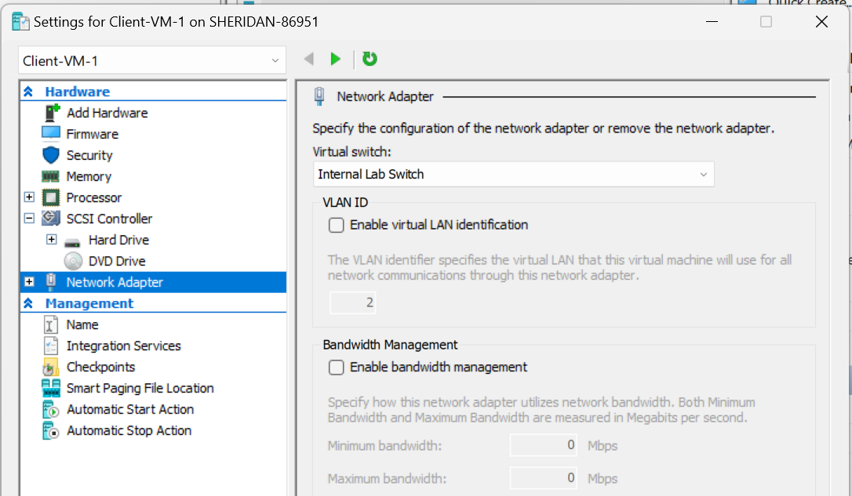
- Decide a subnet to be used for your Windows Administration Lab Set-up.
- For this documentation we have used a network 192.168.1.0/24. It has a default gateway of 192.168.1.1. In the DNS settings you can use DC-1 address, as later in our course this will be configured as DNS server.
Host Computer | 192.168.1.10
DC | 192.168.1.20
- Change the Network Adapter Settings to Manual and configure the IP address according to the table created in step 3.
- Turn off the Windows defender firewall. On Server (DC) and Host Computer in cmd run the following commands to turn off the firewall.
netsh advfirewall firewall add rule name="Allow ICMPv4-In" protocol=icmpv4, 192.168.1.10 dir=in action=allow
netsh advfirewall firewall add rule name=”Allow ICMPv4-Out” protocol=icmpv4, any dir=out action allow
Host Computer
netsh advfirewall firewall add rule name="Allow ICMPv4-In" protocol=icmpv4, 192.168.1.20 dir=in action=allow
netsh advfirewall firewall add rule name=”Allow ICMPv4-Out” protocol=icmpv4, any dir=out action allow
- Check the connectivity among all the devices using ping command.
Following is the result of ping test

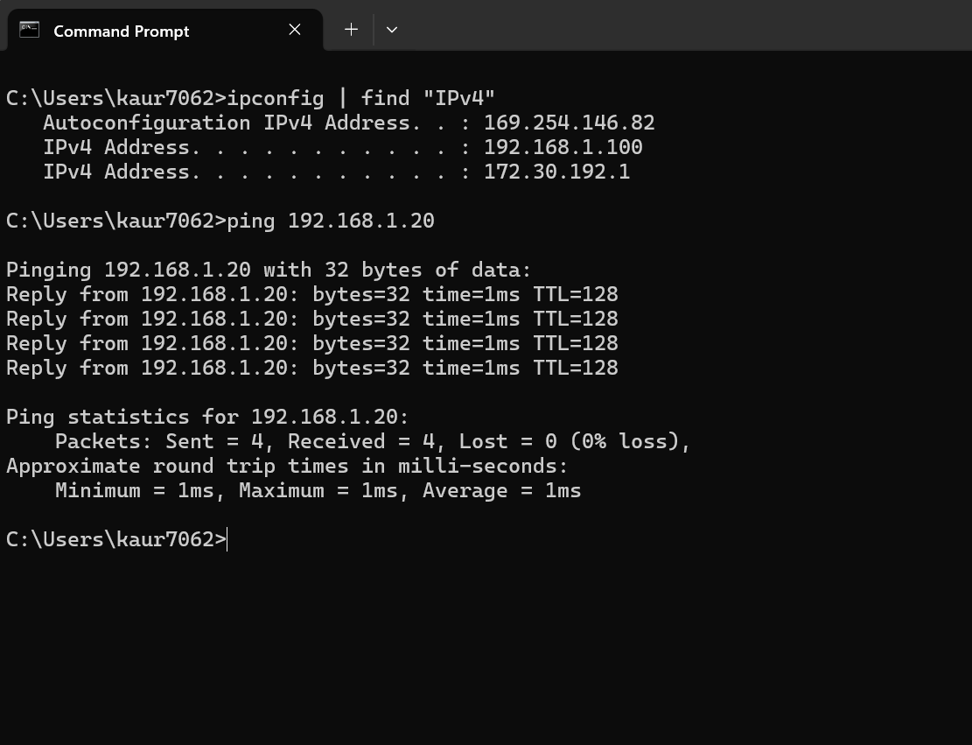

References
Hardware Requirements for Windows Server | Microsoft Learn
Microsoft Copilot. (2025, August 25). Basic Windows Server lab setup diagram [AI-generated image]. Microsoft Copilot. https://copilo.microsoft.com

